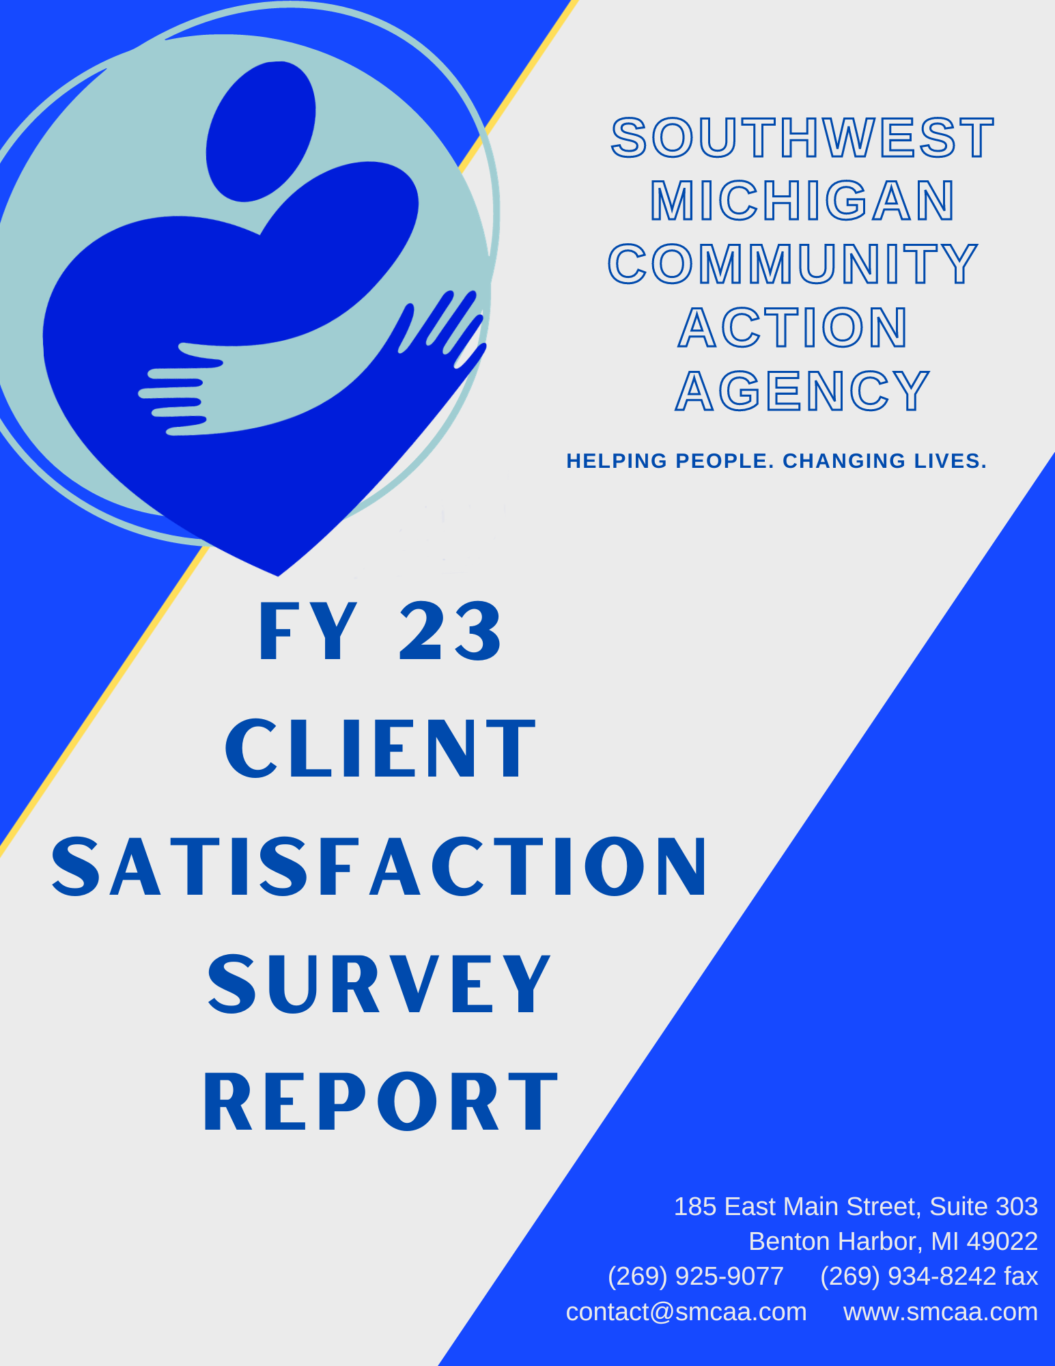
PROJEC

PROJECT OVERVIEW

SMCAA knows the importance of the holistic experience when it comes to meeting the needs of our clients. To properly care for our community, we must strive to not only provide resources, but to include a positive experience where all clients are treated with respect, professionalism, and warmth, so that we can remain a beacon of support in the tri-county area.

Client Satisfaction Surveys were developed as a means of tracking the client experience to ensure we are supporting our mission to “empower diverse people in need and support their journey toward economic security” with every interaction.

Client satisfaction is vital for many reasons:
- It directly affects the clients’ receipt of services and return rate
- It impacts the clients’ level of empowerment, a direct aspect of our mission
- It drives referrals and community awareness
- It is a key component of the ROMA Cycle
- Collected data helps develop SMCAA’s Community Needs Assessment and Strategic Plan
- Competitive grants often review satisfaction results when awarding funding
- It is required by Organizational Standards 1.3 and 6.4
- And much more

METHODS OF DISTRIBUTION

A survey is provided to every client who receives services from SMCAA. Clients may receive multiple surveys if they receive services from more than one program. Information about the survey, its purpose, and length are provided to encourage participation.

Surveys are distributed in a number of ways:
- A link to a digital survey is provided to the client via email
- A hard copy, including a return envelope, is mailed to the client’s home
- The survey is available to complete on the SMCAA.COM homepage
- A hard copy is handed to the client in person, if applicable

Client Satisfaction Survey Goals
- To assess the performance of our client service experience
- To further understand the needs of our clients and community
- To analyze results as a means of making improvements
- Use survey data to inform and shape action and strategy annually
- To address areas of concern and resolve issues

SURVEY COMPLETION RATE

Survey Published: October 1, 2022 Survey Closed: September 30, 2023

Response Data FY 2023 FY 2022
Total Unduplicated Individuals Assisted by SMCAA | 3,087 | 7,621
Total Respondents to Survey | 156 5% | 448 6%
Total Respondents to Online Survey | 5 3% | 36 8%
Total Respondents to Hard Copy Survey | 151 97% | 409 92%
Total of Respondents Who Provided Comments | 65 42% | 278 63%

Take-Aways:
- While the COVID-19 pandemic was winding down in 2022, FY22 data still reflects the greater number of households in need. CERA funding allowed SMCAA to service this higher-than-usual influx of clients, but CERA, as well as other COVID funding sources, was discontinued in 2023.
- While the number of unduplicated individuals services in FY22 compared to FY23 was substantially larger, the percentages of survey responses was comparable.
- In-Person appointments resumed in FY23, possibly resulting in the much larger return of hardcopy surveys as compared to FY22. However, the survey remained online and continued to be emailed to clients. Hard copies also continued to be mailed to clients.

SURVEY QUESTIONS

While responses were requested for all survey questions, hardcopy forms allow the clients to leave areas of the survey unanswered. Unanswered responses were not factored into the following graphs. Survey questions for FY22 and FY 23 remained the same.

WHAT COUNTY DO YOU LIVE IN?

FY 22
- Berrien – 74%
- Cass – 8%
- Van Buren – 18%
- 6 individuals chose not to respond
FY 23
- Berrien – 55%
- Cass – 14%
- Van Buren – 31%
- 4 individuals chose not to respond

HAVE YOU USED SMCAA SERVICES OR PROGRAMS IN THE PAST

This compares to FY22 at 46% yes and 54% no.

HOW DID YOU HEAR ABOUT SMCAA?

Under “Other,” one client wrote in “Self.” No additional sources were noted.
FY22
Family/Friend—38%
Referal from Another Agency—33%
Other—20%
Social Media—3%
Search Engine—4%
Newpaper—1%
(These FY22 numbers when rounded and compiled are 99%; it is unclear where the additional 1% was derived)
WHICH SMCAA SERVICE OR PROGRAM DID YOU RECEIVE DURING YOUR VISIT

Because this question option allows client to select more than one answer, final numbers are larger than the total number of respondants.
Write-in’s for “Other” were “Propane,” and “CERA.”
FY 22
- Food Assistance – 6%
- Utility Assistance – 57%
- Rent/Mortgage Assistance – 26%
- Car Repair/Payment – 1%
- Homeless Shelter – Less than 1%
- Home Repair – 3%
- Weatherization – 4%
- Case Management – 0%
- Other – 3%
FY 23
- Food Assistance – 4%
- Utility Assistance – 25%
- Rent/Mortgage Assistance – 17%
- Car Repair/Payment – 1%
- Homeless Shelter – 6%
- Home Repair – 2%
- Weatherization – 41%
- Case Management – Less than 1%
- Other – 3%

MY NEEDS WERE MET BASED ON THE SERVICES THE PROGRAM COULD PROVIDE

FY22—98% overall satisfied
FY23—97% overall satisfied

I WOULD RECOMMEND THIS PROGRAM IF A FRIEND NEEDED SIMILAR HELP

FY22 and FY23 both showed 98% overall satisfaction in this area.

BECAUSE OF COMMUNITY ACTION’S HELP, I HAVE IMPROVED MY SITUATION

As several clients noted, a determinization on their Weatherization Program application had not yet been made, leaving a grey area in terms of their improvement and a high response rate to “N/A”
FY22—97% overall satisfaction
FY23—98% overall satisfaction
OVERALL, THE QUALITY OF SERVICES I RECEIVED WERE EXCELLENT

FY22 and FY23 both showed 99% overall satisfaction in this area.

STAFF WAS COURTEOUS AND HELPFUL

FY22 and FY23 both showed 99% overall satisfaction in this area.

STAFF LISTENED TO MY CONCERNS

FY 22—97% overall satisfaction
FY 23—98% overall satisfaction

SERVICES WERE PROVIDED TO ME IN A TIMELY MANNER

FY22—96% overall satisfaction
FY23—97% overall satisfaction
STAFF EXPLAINED WHAT I NEEDED TO QUALIFY FOR SERVICE

FY22—97% overall satisfaction
FY23—98% overall satisfaction

STAFF EXPLAINED ALL PAPERWORK TO ME AND ANSWERED MY QUESTIONS

FY22—97% overall satisfaction
FY23—96% overall satisfaction

STAFF TOLD ME ABOUT OTHER SMCAA PROGRAMS THAT MIGHT BE HELPFUL TO ME

FY22—89% overall satisfaction
FY23—92% overall satisfaction

STAFF GAVE ME INFORMATION ABOUT OTHER PROGRAMS OUTSIDE OF SMCAA THAT MIGHT BE HELPFUL TO ME, INCLUDING HOW TO CONTACT THOSE OTHER PROGRAMS

FY22—87% overall satisfaction
FY23—89% overall satisfaction
POSITIVE CLIENT COMMENTS

Of the 65 comments, 56 (86%) were unarguably positive. Positive feedback overwhelmingly and naturally grouped into 3 categories—overall thanks, acknowledgement and appreciation for staff, and praise of service.

THANKS
“Just want to say thank you for your help, my husband had just passed away and I didn’t have money to pay rent that next month. You saved me so I still have a place to live.”
“SMCAA was very helpful to me I just want to say thank you from the bottom of my heart, thank you so much.”
“Thank you so much for the help I couldn’t have done it without you.”
“Thank you so much for your help, I’ve never had to ask for help and I’m 76 years old. But I’m so glad you helped me.”
STAFF ACKNOWLEDGMENT AND APPRECIATION
“I really appreciate the ladies at SMCAA. Very helpful, thoughtful, always help me and my family when in need. Thanks so much.”
“Staff answered all my questions and explained everything thoroughly. They were very friendly and professional. Nathan has always been helpful from the start of the application.”
“Jeremy has made my family crisis situation less stressful. I would like to help if you have any questions.”
“Tammy was very understanding and did everything to help me in my time of need. She also encouraged me to stay strong while going through my child loss.”
“Both Berrien location office workers were very, very nice and kind, they were awesome. I felt the warmth and I was not afraid to express my situation.”
“Staff went above and beyond to help me get documents in order and fill out paperwork to get help. They care and they are great at their jobs!”
“The people were so nice and helpful and I think this place is an awesome place and beneficial to the area.”
“My worker was Tammy Stanton, she worked with me to the end. She lent a listening ear on my first day I called. She is a great worker, caring and understanding person.”
“Over and above Anne was a pleasure, very helpful in every way. Thank you so much.”
“Ms. Johnson is absolutely amazing, and I hope she is appreciated for the amazing, passionate, and compassionate person she is. Thank you so much.”
“Great listener and very courteous! Sarah is great at what she does!”
“Terry is absolutely the best and nicest person I have met. She is sweet and does her job well.”
“Nathan is very helpful and personable. I have not received services yet, only the application/intake.”
SERVICE

“SMCAA helped me when I needed it the most.”
“Done an excellent job for me so far.”
“Overall quick fast and friendly services.”
“Was very pleased with the service, I needed help and they helped me stay in my home.”
“Very timely and professional service. Communication and follow up was exceptional.”
“The service was very helpful without the help I would be out of electric, so thanks for all the help.”
“Things were done in a timely manner. I was very pleased overall.”

COMMENTS ON AREAS FOR IMPROVEMENT

Only 9 comments of the 65 (14%) could be considered non-positive (i.e. negative or neutral).
- “It would be nice to see a list of available assistance programs including what things each agency can help with and what income limits if any will keep a person from getting help.”
Information for partner agency programs is available in detail on our website, and would be too lengthy to include in intake procedures. Qualifications for these many programs are not something that SMCAA would have access to, or be able to provide our clients in many cases. However, this comment does provide some insight into how we can be more transparent about sharing and directing clients toward other available resources.
- “This survey was hard to line up answers with the questions. They should be numbered and have alternating highlighted paths.”
This comment will be noted and taken into consideration for the future.
- “Wish there were more resources given to me to meet my needs more, I am struggling and trying so hard with more stress and debt to my life. I’m low income and have searched all over for assistance in housing and living needs to meet my medical, financial, emotional needs.”
- “I can’t remember if they gave me information about other programs for help during my visit that day.”
Comments 3 and 4 are another indication that staff can improve when it comes to sharing partner resources.
- “One concern would be to allow all agencies to share my information more freely to help speed up the entire process if possible. Overall excellent professional behavior and attitudes.”
While we understand and relate to this frustration, SMCAA is unable to access, share, or receive client information from other agencies. Agencies are required (to varying degrees) to protect participant confidentiality by not sharing their clients’ information with outside agencies. This makes information exchange difficult-to-impossible for SMCAA.
- “Have been out of propane since January and contacted SMCAA and was told they could help with $300. DHS approved us for $300 and we were told we had to pay $143. We paid our $143 to S&F Propane and sent them the information. I have been emailing and calling and leaving messaged and have not had a return email or phone call from anyone in the past week of trying to figure out why I’m not getting assistance or if anything else is needed from me.”
When they arrived at the agency this client did not provide the documentation that would prove SMCAA’s payment would resolve their emergency. Staff did try several times to contact them and could not get a response. There is no evidence this client reached out to SMCAA via voicemails or emails. This client did receive funding from SMCAA.
- “Problem was told to be at Cass on Tuesday, no one was there I had to wait until Thursday. Inconvenient with misinformation.”
We were unable to reach this client to confirm any miscommunications. This client was referred to Helping Hands, and received funding for propane multiples times through our agency.
- “I need help paying back rent, somebody stole my money and they won’t give it back.”

There was no contact information available for this client for follow-up.
- One client noted several areas of concern throughout the survey. He marked that he applied for food assistance, utility assistance, and rent/mortgage assistance, with comments that he needed the “emergency food box,” and his “water bill only. Was told no funding for gas bill.” He noted that “Landlord was still not paid as of 3/18/23” as his reasoning for opting “disagree” under the survey question “Services were provided to me in a timely manner. He also marked disagreeing with “My needs were met based on the services this program could provide me,” where he again noted “also need help with gas bill.”
As this client provided his contact information, his case was reviewed and it should be noted he had received $475.00 rental assistance on 2/22/23, $203.04 for water bills also in February, and that his landlord was paid on 3/22/23. In March, he was also credited $1,281.00 in total toward his gas bill. He was provided provisions from the food pantry and additionally signed up for CSFP/TEFAP food distribution but has never picked up his food boxes for these programs. Overall, in 2023 this client was paid out over $1,959.00
CLIENT SATISFACTION SURVEY RESULTS

KEY TAKEAWAYS
- There was a notable drop in clients who took the Client Satisfaction Survey online (8% in FY22, with just 3% in FY23). While, as addressed, some of this may be contributed to the resumption of in-person applications, it is something to consider for the future. With only a 5% total return of surveys, ensuring clients are aware of their survey-taking options is pivotal to increasing return rate.
- Comparable to previous years, awareness of SMCAA and its programs is driven substantially by referrals from other agencies (33%) and word-of-mouth (37%). This shows that we have massive potential to increase awareness from other channels, especially search engine (4%) and social media (3%).
- FY23 saw a major revaluing of services as compared to FY22.
  - Most significantly, clients involved in the Weatherization Assistance Program jumped from 4% to an incredible 41%. We believe this can largely be attributed to a change in management and a focus on “de-siloing” the Weatherization Department, as well as the completion of a stable and fully-staffed team.
  - While there was a major drop in utility clients (57% to 25% in FY23), it is most likely due to a drop in utility funding in FY23.
  - Homeless Shelter services rose from less than 1% to 6% in FY23—while it appears a concerning trend, it can more likely be attributed to a reminder to Shelter staff to distribute surveys upon client exit, and thus increased survey return.
  - Car Repair/Payment services have also run out of funding and discontinued, resulting in low responses.
  - Case Management is a point of contention and confusion when offered as a service in this survey, as most would consider it related, rather than separate, from the suggested programs. This will be considered for removal for future surveys.
  - The drop in Food Assistance (FY22—6% to FY23—4%) could potentially be a result of the new three-year eligibility rates for CSFP. This simply means that since applications carry over, there are fewer surveys distributed to new clients.
- The lowest points of client satisfaction continue to be the same as FY22, being “Staff told me about other SMCAA programs that might be helpful to me” (FY22—89%, FY23—92%) and “Staff gave me information about other programs outside of SMCAA that might be helpful to me, including how to contact those other programs” (FY22—87%, FY23—89%). While they are on the increase as compared to the previous fiscal year, satisfaction ratings and comments show there remains room for improvement in these areas. As a component of de-siloing the Weatherization Department, Weatherization staff is now being cross-trained in all programs and will be able to further assist clients with sharing additional program information.
- Only two survey questions showed a slight decline in satisfaction, “My needs were met based on the services this program could provide to me,” (FY22—98%, FY23—97%), and “Staff explained all paperwork to me and answered my questions” (FY22—97%, FY23—96%). While a decrease in funding available during the height of COVID-19 could provide a potential reasoning to why clients’ needs are being met at a lesser level, staff training will continue to stress the importance of explaining paperwork, referring clients to programs both inside and outside of SMCAA, and being available for questions.
- Despite this, overall comments were glowingly positive, not only for the organization and its services, but particularly for the staff’s attitude and aid.

